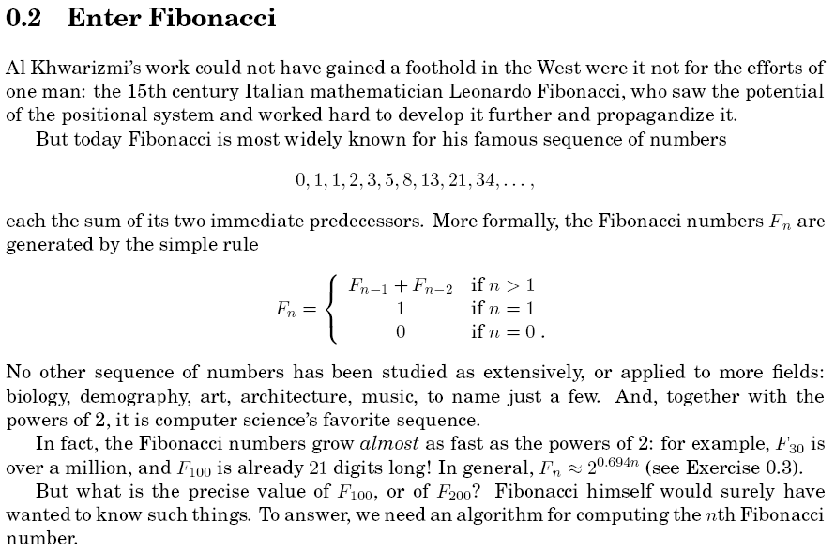

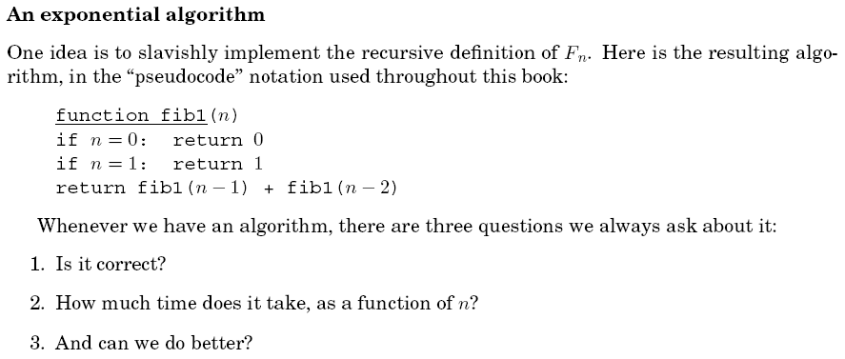

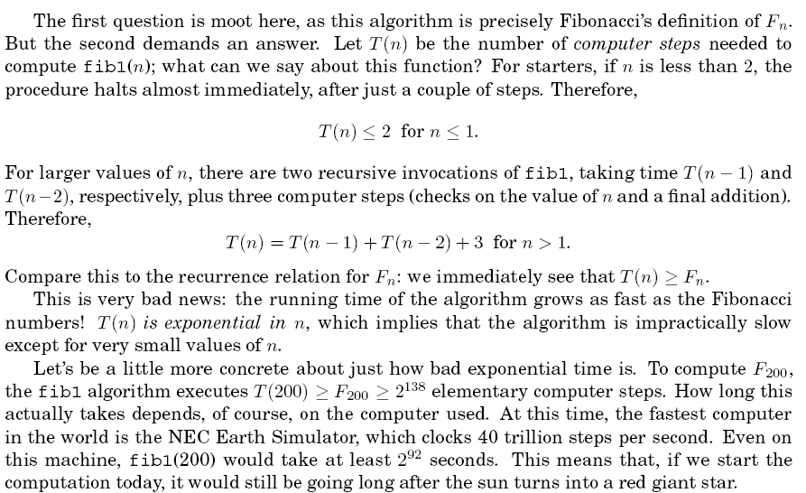

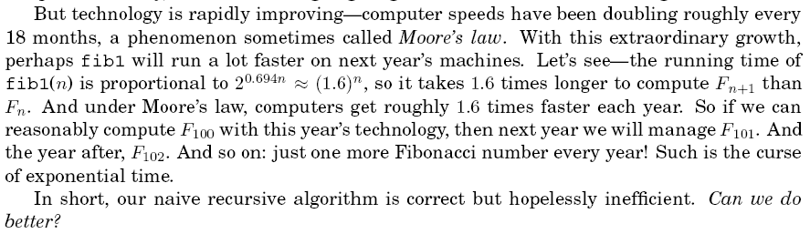

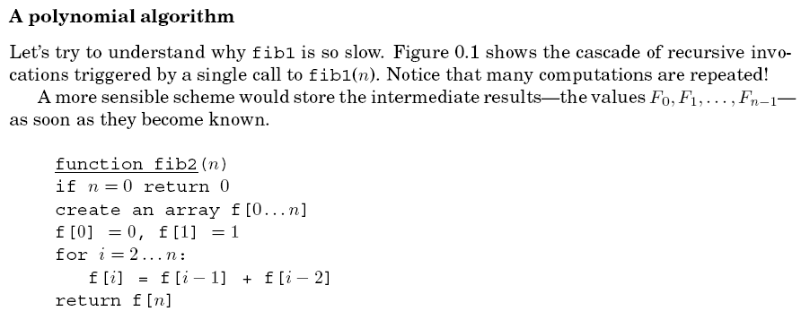

**Golden Ratio & Golden Section : : Golden Rectangle : : Golden Spiral**

**Golden Ratio & Golden Section**

In mathematics and the arts, two quantities are in the **golden ratio** if the ratio between the sum of those quantities and the larger one is the same as the ratio between the larger one and the smaller.

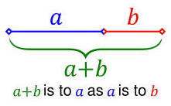

Expressed algebraically:

http://www.world-mysteries.com/sci_172.gif

**The golden ratio** is often denoted by the Greek letter phi (Φ or φ).   
The figure of **a golden section** illustrates the geometric relationship that defines this constant. The golden ratio is an irrational mathematical constant, approximately **1.6180339887.**

**Golden Rectangle**

A **golden rectangle** is a rectangle whose side lengths are in the **golden ratio**, 1: (one-to-phi),   
that is, 1 :  or approximately 1:1.618.

|  |  |
| --- | --- |
| A golden rectangle can be constructed with only straightedge  and compass by this technique:   1. Construct a simple square 2. Draw a line from the midpoint of one side of the square to an opposite corner 3. Use that line as the radius to draw an arc that defines the height of the rectangle 4. Complete the golden rectangle | http://www.world-mysteries.com/sci_171.jpg |

**Golden Spiral**

In geometry, a **golden spiral**is a logarithmic spiral whose growth factor b is related to , the golden ratio. Specifically, a golden spiral gets wider (or further from its origin) by a factor of for every quarter turn it makes.

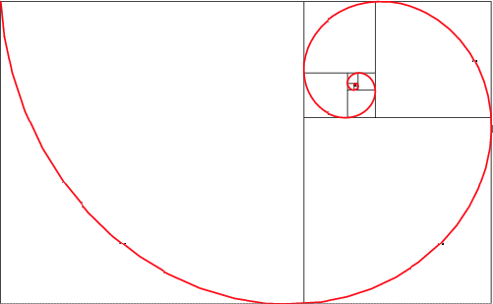  
*Successive points dividing a golden rectangle into squares lie on   
a logarithmic spiral which is sometimes known as the golden spiral.   
Image Source:*[*http://mathworld.wolfram.com/GoldenRatio.html*](http://mathworld.wolfram.com/GoldenRatio.html)

**Golden Ratio in Architecture and Art**

Many  architects and artists have proportioned their works to approximate the golden ratio—especially in the form of the **golden rectangle**, in which the ratio of the longer side to the shorter is the golden ratio—believing this proportion to be aesthetically pleasing. [*Source:*Wikipedia.org]

**Here are few examples:**

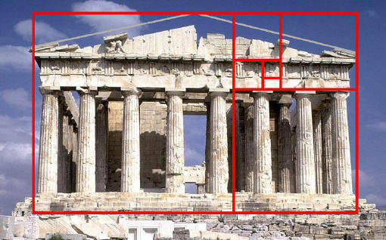  
*Parthenon, Acropolis, Athens.  
 This ancient temple fits almost precisely into a golden rectangle.  
Source:*[*http://britton.disted.camosun.bc.ca/goldslide/jbgoldslide.htm*](http://britton.disted.camosun.bc.ca/goldslide/jbgoldslide.htm)

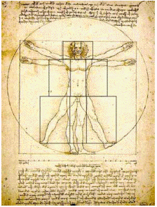  
*The Vetruvian Man"(The Man in Action)" by Leonardo Da Vinci  
We can draw many lines of the rectangles into this figure.   
Then, there are three distinct sets of Golden Rectangles:   
Each one set for the head area, the torso, and the legs.*[*Image Source >>*](http://jwilson.coe.uga.edu/EMT668/EMAT6680.2000/Obara/Emat6690/Golden%20Ratio/golden.html)

Leonardo's *Vetruvian Man* is sometimes confused with principles of  "golden rectangle", however that is not the case. The construction of Vetruvian Man is based on drawing a circle with its diameter equal to diagonal of the square, moving it up so it would touch the base of the square and drawing the final circle between the base of the square and the mid-point between square's center and center of the moved circle:

[Detailed explanation about  geometrical construction of the Vitruvian Man by Leonardo da Vinci >>](http://www.world-mysteries.com/sci_17_vm.htm)

**Golden Ratio in Nature**

Adolf Zeising, whose main interests were mathematics and philosophy, found the golden ratio expressed in the arrangement of branches along the stems of plants and of veins in leaves. He extended his research to the skeletons of animals and the branchings of their veins and nerves, to the proportions of chemical compounds and the geometry of crystals, even to the use of proportion in artistic endeavors. In these phenomena he saw the golden ratio operating as a universal law.[38] Zeising wrote in 1854:

*The Golden Ratio is a universal law in which is contained the ground-principle of all formative striving for beauty and completeness in the realms of both nature and art, and which permeates, as a paramount spiritual ideal, all structures, forms and proportions, whether cosmic or individual, organic or inorganic, acoustic or optical; which finds its fullest realization, however, in the human form.*

**Examples:**

[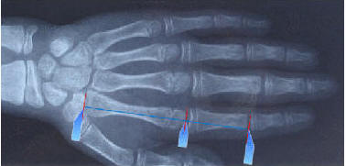](http://www.world-mysteries.com/sci_17_hand.gif)  
*Click on the picture for animation showing more examples of golden ratio.  
Source:*<http://www.xgoldensection.com/xgoldensection.html>

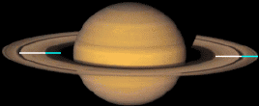

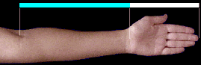  
  
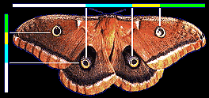  
*Source:* <http://www.goldennumber.net/hand.htm>

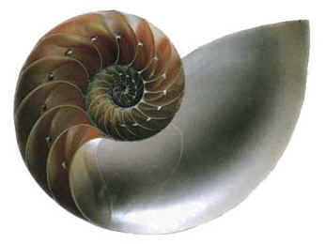  
*A slice through a Nautilus shell reveals   
golden spiral construction principle.*

**FIBONACCI NUMBERS**

**About Fibonacci**

Fibonacci was known in his time and is still recognized today as the "greatest European mathematician of the middle ages." He was born in the 1170's and died in the 1240's and there is now a statue commemorating him located at the Leaning Tower end of the cemetery next to the Cathedral in Pisa. Fibonacci's name is also perpetuated in two streetsthe quayside Lungarno Fibonacci in Pisa and the Via Fibonacci in Florence.  
His full name was Leonardo of Pisa, or Leonardo Pisano in Italian since he was born in Pisa.  He called himself Fibonacci which was short for Filius Bonacci, standing for "son of Bonacci", which was his father's name. Leonardo's father( Guglielmo Bonacci) was a kind of customs officer in the North African town of Bugia, now called Bougie. So Fibonacci grew up with a North African education under the Moors and later travelled extensively around the Mediterranean coast. He then met with many merchants and learned of their systems of doing arithmetic. He soon realized the many advantages of the "Hindu-Arabic" system over all the others. He was one of the first people to introduce the Hindu-Arabic number system into Europe-the system we now use today- based of ten digits with its decimal point and a symbol for zero: 1 2 3 4 5 6 7 8 9. and 0  
His book on how to do arithmetic in the decimal system, called *Liber abbaci*(meaning Book of the Abacus or Book of calculating) completed in 1202 persuaded many of the European mathematicians of his day to use his "new" system. The book goes into detail (in Latin) with the rules we all now learn in elementary school for adding, subtracting, multiplying and dividing numbers altogether with many problems to illustrate the methods in detail.  (<http://www.mcs.surrey.ac.uk/Personal/R.Knott/Fibonacci/fibnat.html#Rabbits> )

**Fibonacci Numbers**

The sequence, in which **each number is the sum of the two preceding numbers** is known as the **Fibonacci series:** 1, 1, 2, 3, 5, 8, 13, 21, 34, 55, 89, 144, 233, 377, 610, 987, 1597, 2584, 4181, ...  (each number is the sum of the previous two).

The ratio of successive pairs is so-called **golden section** (GS) - 1.618033989 . . . . .   
whose reciprocal is 0.618033989 . . . . . so that we have 1/GS = 1 + GS.

The **Fibonacci sequence,** generated by the rule f1 = f2 = 1 , fn+1 = fn + fn-1,  
is well known in many different areas of mathematics and science.

**Pascal's Triangle and Fibonacci Numbers**

The triangle was studied by B. Pascal, although it had been described centuries earlier by Chinese mathematician Yanghui (about 500 years earlier, in fact) and the Persian astronomer-poet Omar Khayyám.

Pascal's Triangle is described by the following formula:

http://www.world-mysteries.com/fib_p1img1427.gif

where http://www.world-mysteries.com/fib_p1img1428.gif is a [binomial coefficient](http://mathworld.wolfram.com/BinomialCoefficient.html).

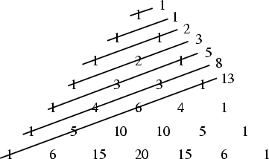

*The "shallow diagonals" of Pascal's triangle   
sum to Fibonacci numbers.*

**It is quite amazing that the Fibonacci number patterns occur so frequently in nature**( flowers, shells, plants, leaves, to name a few) that this phenomenon appears to be one of the principal "laws of nature". Fibonacci sequences appear in biological settings, in two consecutive Fibonacci numbers, such as branching in trees, arrangement of leaves on a stem, the fruitlets of a pineapple, the flowering of artichoke, an uncurling fern and the arrangement of a pine cone. In addition, numerous claims of Fibonacci numbers or golden sections in nature are found in popular sources, e.g. relating to the breeding of rabbits, the spirals of shells, and the curve of waves  The Fibonacci numbers are also found in the family tree of honeybees.

**Fibonacci and****Nature**

Plants do not know about this sequence - they just grow in the most efficient ways. Many plants show the Fibonacci numbers in the arrangement of the leaves around the stem. Some pine cones and fir cones also show the numbers, as do daisies and sunflowers. Sunflowers can contain the number 89, or even 144. Many other plants, such as succulents, also show the numbers. Some coniferous trees show these numbers in the bumps on their trunks. And palm trees show the numbers in the rings on their trunks.

Why do these arrangements occur? In the case of leaf arrangement, or phyllotaxis, some of the cases may be related to maximizing the space for each leaf, or the average amount of light falling on each one. Even a tiny advantage would come to dominate, over many generations. In the case of close-packed leaves in cabbages and succulents the correct arrangement may be crucial for availability of space.  This is well described in several books listed [here >>](http://www.world-mysteries.com/sci_17.htm#Books)

So nature isn't trying to use the Fibonacci numbers: they are appearing as a by-product of a deeper physical process. That is why the spirals are imperfect.   
The plant is responding to physical constraints, not to a mathematical rule.

The basic idea is that the position of each new growth is about 222.5 degrees away from the previous one, because it provides, on average, the maximum space for all the shoots. This angle is called the **golden angle**, and it divides the complete 360 degree circle in the golden section, 0.618033989 . . . .

**Examples of the Fibonacci sequence in nature.**

**Petals on flowers\***

Probably most of us have never taken the time to examine very carefully the number or arrangement of petals on a flower. If we were to do so, we would find that the number of petals on a flower, that still has all of its petals intact and has not lost any, for many flowers is a Fibonacci number:

* 3 petals: lily, iris
* 5 petals: buttercup, wild rose, larkspur, columbine (aquilegia)
* 8 petals: delphiniums
* 13 petals: ragwort, corn marigold, cineraria,
* 21 petals: aster, black-eyed susan, chicory
* 34 petals: plantain, pyrethrum
* 55, 89 petals: michaelmas daisies, the asteraceae family

Some species are very precise about the number of petals they have - e.g. buttercups, but others have petals that are very near those above, with the average being a Fibonacci number.

|  |  |
| --- | --- |
| One-petalled ...             *white calla lily* | [http://www.world-mysteries.com/fib01sm.jpg](http://ccins.camosun.bc.ca/~jbritton/fibslide/fib01.jpg) |
| Two-petalled flowers are not common.        *euphorbia* | [http://www.world-mysteries.com/fib02sm.jpg](http://ccins.camosun.bc.ca/~jbritton/fibslide/fib02.jpg) |
| Three petals are more common.        *trillium* | [http://www.world-mysteries.com/fib03sm.jpg](http://ccins.camosun.bc.ca/~jbritton/fibslide/fib03.jpg) |
| Five petals - there are hundreds of species, both wild and cultivated, with five petals. | http://www.world-mysteries.com/fib_flow5.jpg |
| Eight-petalled flowers are not so common as five-petalled, but there are quite a number of well-known species with eight.      *bloodroot* | [http://www.world-mysteries.com/fib05sm.jpg](http://ccins.camosun.bc.ca/~jbritton/fibslide/fib05.jpg) |
| Thirteen, ...        *black-eyed susan* | [http://www.world-mysteries.com/fib06sm.jpg](http://ccins.camosun.bc.ca/~jbritton/fibslide/fib06.jpg) |
| Twenty-one and thirty-four petals are also quite common. The outer ring of ray florets in the daisy family illustrate the Fibonacci sequence extremely well.  Daisies with 13, 21, 34, 55 or 89 petals are quite common.    *shasta daisy with 21 petals* | [http://www.world-mysteries.com/fib07sm.jpg](http://ccins.camosun.bc.ca/~jbritton/fibslide/fib07.jpg) |
| Ordinary *field daisies* have 34 petals ...  a fact to be taken in consideration when playing "she loves me, she loves me not". In saying that daisies have 34 petals, one is generalizing about the species - but any individual member of the species may deviate from this general pattern. There is more likelihood of a possible under development than over-development, so that 33 is more common than 35. | [http://www.world-mysteries.com/fib08sm.jpg](http://ccins.camosun.bc.ca/~jbritton/fibslide/fib08.jpg) |

*\* Read the entire article here:*<http://britton.disted.camosun.bc.ca/fibslide/jbfibslide.htm>

*Related Links:<http://britton.disted.camosun.bc.ca/jbfunpatt.htm>*

**Flower Patterns and Fibonacci Numbers**

Why is it that the number of petals in a flower is often one of the following numbers: 3, 5, 8, 13, 21, 34 or 55? For example, the lily has three petals, buttercups have five of them, the chicory has 21 of them, the daisy has often 34 or 55 petals, etc. Furthermore, when one observes the heads of sunflowers, one notices two series of curves, one winding in one sense and one in another; the number of spirals not being the same in each sense. Why is the number of spirals in general either 21 and 34, either 34 and 55, either 55 and 89, or 89 and 144? The same for pinecones : why do they have either 8 spirals from one side and 13 from the other, or either 5 spirals from one side and 8 from the other? Finally, why is the number of diagonals of a pineapple also 8 in one direction and 13 in the other?

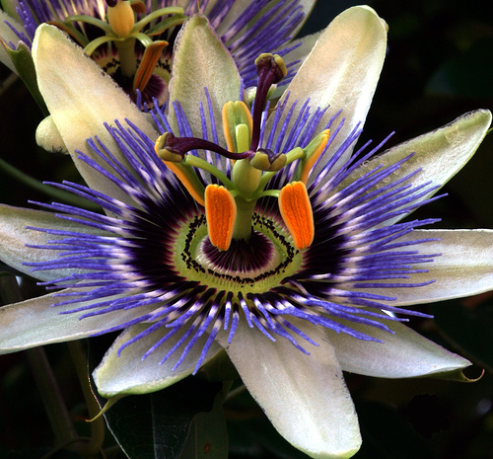  
*Passion Fruit   
© All rights reserved*[Image Source >>](http://www.flickr.com/photos/finbar/271323097/" \t "_blank)

Are these numbers the product of chance? No! They all belong to the Fibonacci sequence: **1, 2, 3, 5, 8, 13, 21, 34, 55, 89, 144**, etc. (where each number is obtained from the sum of the two preceding). A more abstract way of putting it is that the Fibonacci numbers fn are given by the formula f1 = 1, f2 = 2, f3 = 3, f4 = 5 and generally f n+2 = fn+1 + fn . For a long time, it had been noticed that these numbers were important in nature, but only relatively recently that one understands why. It is a question of efficiency during the growth process of plants.

The explanation is linked to another famous number, the golden mean, itself intimately linked to the spiral form of certain types of shell. Let's mention also that in the case of the **sunflower**, the pineapple and of the pinecone, the correspondence with the Fibonacci numbers is very exact, while in the case of the number of flower petals, it is only verified on average (and in certain cases, the number is doubled since the petals are arranged on two levels).

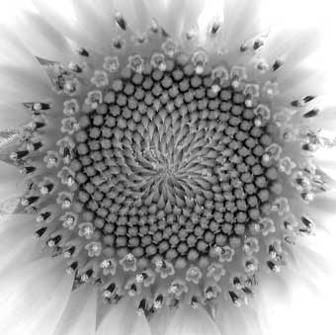  
*© All rights reserved.*

Let's underline also that although Fibonacci historically introduced these numbers in 1202 in attempting to model the growth of populations of rabbits, this does not at all correspond to reality! On the contrary, as we have just seen, his numbers play really a fundamental role in the context of the growth of plants

**THE EFFECTIVENESS OF THE GOLDEN MEAN**

The explanation which follows is very succinct. For a much more detailed explanation, with very interesting animations, see the web site in the reference.

In many cases, the head of a flower is made up of small seeds which are produced at the centre, and then migrate towards the outside to fill eventually all the space (as for the sunflower but on a much smaller level). Each new seed appears at a certain angle in relation to the preceeding one. For example, if the angle is 90 degrees, that is 1/4 of a turn, the result after several generations is that represented by figure 1.

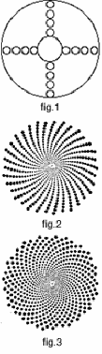

Of course, this is not the most efficient way of filling space. In fact, if the angle between the appearance of each seed is a portion of a turn which corresponds to a simple fraction, 1/3, 1/4, 3/4, 2/5, 3/7, etc (that is a simple rational number), one always obtains a series of straight lines. If one wants to avoid this rectilinear pattern, it is necessary to choose a portion of the circle which is an irrational number (or a nonsimple fraction). If this latter is well approximated by a simple fraction, one obtains a series of curved lines (spiral arms) which even then do not fill out the space perfectly (figure 2).

In order to optimize the filling, it is necessary to choose the most irrational number there is, that is to say, the one the least well approximated by a fraction. This number is exactly the golden mean. The corresponding angle, the golden angle, is 137.5 degrees. (It is obtained by multiplying the non-whole part of the golden mean by 360 degrees and, since one obtains an angle greater than 180 degrees, by taking its complement). With this angle, one obtains the optimal filling, that is, the same spacing between all the seeds (figure 3).

This angle has to be chosen very precisely: variations of 1/10 of a degree destroy completely the optimization. (In fig 2, the angle is 137.6 degrees!) When the angle is exactly the golden mean, and only this one, two families of spirals (one in each direction) are then visible: their numbers correspond to the numerator and denominator of one of the fractions which approximates the golden mean : 2/3, 3/5, 5/8, 8/13, 13/21, etc.

These numbers are precisely those of the Fibonacci sequence (the bigger the numbers, the better the approximation) and the choice of the fraction depends on the time laps between the appearance of each of the seeds at the center of the flower.

This is why the number of spirals in the centers of sunflowers, and in the centers of flowers in general, correspond to a Fibonacci number. Moreover, generally the petals of flowers are formed at the extremity of one of the families of spiral. This then is also why the number of petals corresponds on average to a Fibonacci number.

**REFERENCES:**

1. An excellent Internet [site of  Ron Knot's](http://www.mcs.surrey.ac.uk/Personal/R.Knott/Fibonacci/fibnat.html)at the University of Surrey on this and related topics.
2. S. Douady et Y. Couder, La physique des spirales végétales, La Recherche, janvier 1993, p. 26 (In French).

*Source of the above segment:*[*http://www.popmath.org.uk/rpamaths/rpampages/sunflower.html*](http://www.popmath.org.uk/rpamaths/rpampages/sunflower.html)*© Mathematics and Knots, U.C.N.W.,Bangor, 1996 - 2002*

**Fibonacci numbers in vegetables and fruit**

Romanesque Brocolli/Cauliflower (or Romanesco) looks and tastes like a cross between brocolli and cauliflower. Each floret is peaked and is an identical but smaller version of the whole thing and this makes the spirals easy to see.

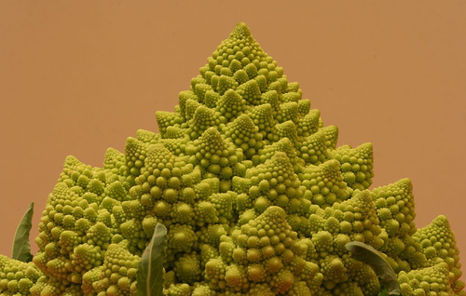

*Brocolli/Cauliflower  
© All rights reserved*[*Image Source >>*](http://www.mcs.surrey.ac.uk/Personal/R.Knott/Fibonacci/fibnat.html)

\* \* \*

**Human Hand**

Every human has two hands, each one of these has five fingers, each finger has three parts which are separated by two knuckles. All of these numbers fit into the sequence. However keep in mind, this could simply be coincidence.

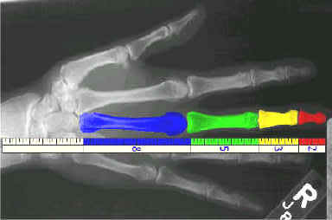

To view more examples of Fibonacci numbers in Nature explore our selection of [related links>>](http://www.world-mysteries.com/sci_17.htm#Links).

**Human Face**

Knowledge of the golden section, ratio and rectangle goes back to the Greeks, who based their most famous work of art on them: the Parthenon is full of golden rectangles. The Greek followers of the mathematician and mystic Pythagoras even thought of the golden ratio as divine.

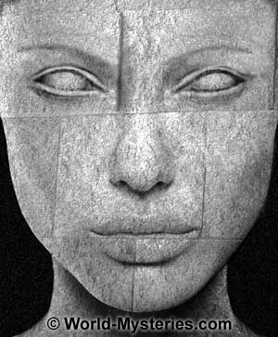

Later, Leonardo da Vinci painted Mona Lisa's face to fit perfectly into a golden rectangle, and structured the rest of the painting around similar rectangles.

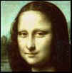

Mozart divided a striking number of his sonatas into two parts whose lengths reflect the golden ratio, though there is much debate about whether he was conscious of this. In more modern times, Hungarian composer Bela Bartok and French architect Le Corbusier purposefully incorporated the golden ratio into their work.

Even today, the golden ratio is in human-made objects all around us. Look at almost any Christian cross; the ratio of the vertical part to the horizontal is the golden ratio. To find a golden rectangle, you need to look no further than the credit cards in your wallet.

Despite these numerous appearances in works of art throughout the ages, there is an ongoing debate among psychologists about whether people really do perceive the golden shapes, particularly the golden rectangle, as more beautiful than other shapes. In a 1995 article in the journal Perception, professor Christopher Green,   
of York University in Toronto, discusses several experiments over the years that have shown no measurable preference for the golden rectangle, but notes that several others have provided evidence suggesting such a preference exists.

Regardless of the science, the golden ratio retains a mystique, partly because excellent approximations of it turn up in many unexpected places in nature. The spiral inside a nautilus shell is remarkably close to the golden section, and the ratio of the lengths of the thorax and abdomen in most bees is nearly the golden ratio. Even a cross section of the most common form of human DNA fits nicely into a golden decagon. The golden ratio and its relatives also appear in many unexpected contexts in mathematics, and they continue to spark interest in the mathematical community.

Dr. Stephen Marquardt, a former [plastic surgeon](http://www.plasticsurgeryguide.com/), has used the golden section, that enigmatic number that has long stood for beauty, and some of its relatives to make a mask that he claims is the most beautiful shape a human face can have.

*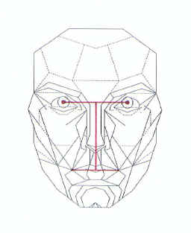*[*The Mask*](http://www.beautyanalysis.com/images/RFMask_printable.jpg)*of a perfect human face*

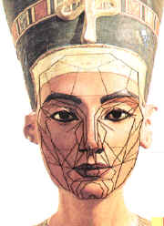

*Egyptian Queen Nefertiti (1400 B.C.)*

*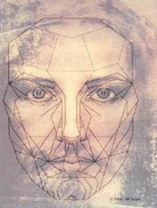*

*An artist's impression of the face of Jesus   
based on the Shroud of Turin and corrected   
to match Dr. Stephen Marquardt's mask.*[*Click here for more detailed analysis.*](http://www.world-mysteries.com/jesus.htm)

*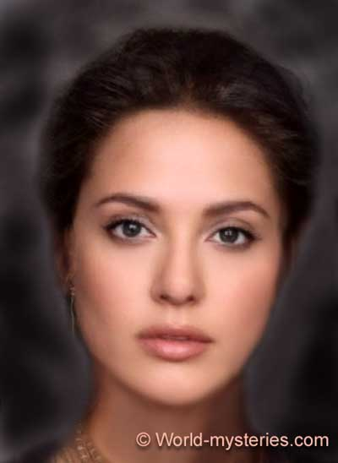*

*"Averaged" (morphed) face of few celebrities.  
Related website:*[*http://www.faceresearch.org/tech/demos/average*](http://www.faceresearch.org/tech/demos/average)

You can overlay the [Repose Frontal Mask](http://www.beautyanalysis.com/mba_reposefrontalmaskapplication_page.htm) (also called the RF Mask or Repose Expression – Frontal View Mask) over a photograph of your own face to help you apply makeup, to aid in evaluating your face for [face lift surgery](http://www.plasticsurgeryguide.com/facelift.html), or simply to see how much your face conforms to the measurements of the Golden Ratio.

Visit [Dr. Marquardt's Web site](http://www.beautyanalysis.com/index2_mba.htm) for more information on the [beauty mask.](http://www.beautyanalysis.com/mba_youandthemask_page.htm)

Source of the above article (with exception of few added photos):<http://tlc.discovery.com/convergence/humanface/articles/mask.html>

**Related links:**

* Dr. Marquardt's Web site
* [The Beauty Code](http://www.beautyanalysis.com/MBA_thebeautycodeTOP_page.htm)
* [Cross-Cultural Beauty](http://www.beautyanalysis.com/mba_contemporarybeauty_page.htm)
* [Timeless Beauty](http://www.beautyanalysis.com/mba_formererasbeauty_page.htm)
* [Beauty Ranges](http://www.beautyanalysis.com/mba_beautyranges_page.htm)

***Related websites***

* [*http://www.faceresearch.org/tech/demos/average*](http://www.faceresearch.org/tech/demos/average)
* [*http://morph.cs.st-andrews.ac.uk/fof/index.html*](http://morph.cs.st-andrews.ac.uk/fof/index.html)
* [*http://digitalphotopix.com/people/the-face-of-tomorrow/*](http://digitalphotopix.com/people/the-face-of-tomorrow/)

[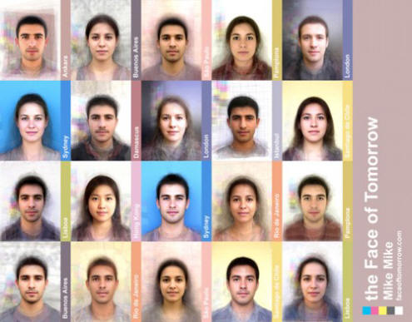](http://digitalphotopix.com/people/the-face-of-tomorrow/)

**Fibonacci's Rabbits**

The original problem that Fibonacci investigated, in the year 1202, was about how fast rabbits could breed in ideal circumstances. "A pair of rabbits, one month old, is too young to reproduce. Suppose that in their second month, and every month thereafter, they produce a new pair. If each new pair of rabbits does the same, and none of the rabbits dies, how many pairs of rabbits will there be at the beginning of each month?"

1. At the end of the first month, they mate, but there is still one only 1 pair.
2. At the end of the second month the female produces a new pair, so now there are 2 pairs of rabbits in the field.
3. At the end of the third month, the original female produces a second pair, making 3 pairs in all in the field.
4. At the end of the fourth month, the original female has produced yet another new pair, the female born two months ago produces her first pair also, making 5 pairs. (<http://www.mcs.surrey.ac.uk/Personal/R.Knott/Fibonacci/fibBio.html>)

The number of pairs of rabbits in the field at the start of each month is 1, 1, 2, 3, 5, 8, 13, 21, etc.

**The Fibonacci Rectangles and Shell Spirals**

We can make another picture showing the Fibonacci numbers 1,1,2,3,5,8,13,21,.. if we start with two small squares of size 1 next to each other. On top of both of these draw a square of size 2 (=1+1).

|  |  |
| --- | --- |
| http://www.world-mysteries.com/fibspiralanm.gif | http://www.world-mysteries.com/fibspiral.gif |

[[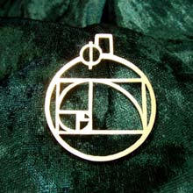](http://www.ka-gold-jewelry.com/p-products/phi-gold.php?ref=786)  
Phi pendant gold - a Powerful Tool for Finding Harmony and Beauty](http://www.ka-gold-jewelry.com/p-products/phi-gold.php?ref=786)

We can now draw a new square - touching both a unit square and the latest square of side 2 - so having sides 3 units long; and then another touching both the 2-square and the 3-square (which has sides of 5 units). We can continue adding squares around the picture, **each new square having a side which is as long as the sum of the latest two square's sides**. This set of rectangles whose sides are two successive Fibonacci numbers in length and which are composed of squares with sides which are Fibonacci numbers, we will call the **Fibonacci Rectangles**.

The next diagram shows that we can draw a spiral by putting together quarter circles, one in each new square. This is a spiral (the **Fibonacci Spiral**). A similar curve to this occurs in nature as the shape of a snail shell or some sea shells. Whereas the Fibonacci Rectangles spiral increases in size by a factor of Phi (1.618..) in a *quarter of a turn* (i.e. a point a further quarter of a turn round the curve is 1.618... times as far from the centre, and this applies to *all* points on the curve), the Nautilus spiral curve takes a *whole turn* before points move a factor of 1.618... from the centre.

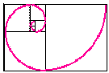

  
*A slice through a Nautilus shell*

These spiral shapes are called [Equiangular](http://www-groups.dcs.st-and.ac.uk/~history/Curves/Equiangular.html) or [Logarithmic spirals](http://www.notam.uio.no/~oyvindha/loga.html). The links from these terms contain much more information on these curves and pictures of computer-generated shells.

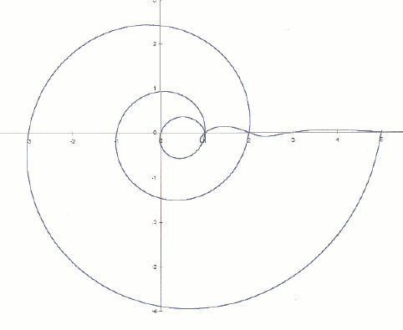

*Here is a curve which crosses the X-axis at the Fibonacci numbers*

The spiral part crosses at 1 2 5 13 etc on the positive axis, and 0 1 3 8 etc on the negative axis. The oscillatory part crosses at 0 1 1 2 3 5 8 13 etc on the positive axis. The curve is strangely reminiscent of the shells of Nautilus and snails. This is not surprising, as the curve tends to a logarithmic spiral as it expands.

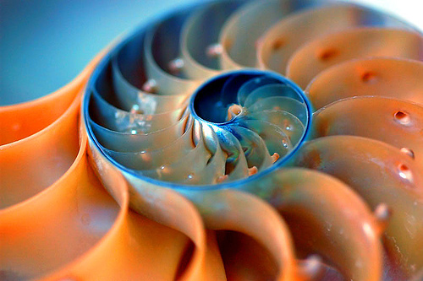

*Nautilus shell (cut)   
© All rights reserved.*[*Image source >>*](http://www.flickr.com/photos/kenilio/117731641/in/set-72057594094457868/)

[[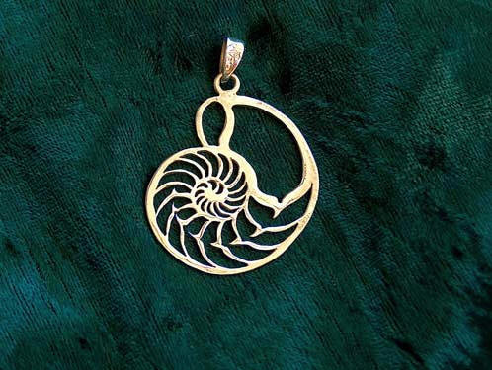](http://www.ka-gold-jewelry.com/p-products/nautilus-gold.php?ref=786)  
Nautilus jewelry pendant gold - A Symbol of Nature’s Beauty](http://www.ka-gold-jewelry.com/p-products/nautilus-gold.php?ref=786)

**Proportion - Golden Ratio and Rule of Thirds**

*© R. Berdan 20/01/2004. Published with permission of the author*

[[http://www.world-mysteries.com/up.jpg](http://www.world-mysteries.com/sci_17.htm#top)](http://www.world-mysteries.com/sci_17.htm#top)

Proportion refers the size relationship of visual elements to each other and to the whole picture. One of the reasons proportion is often considered important in composition is that viewers respond to it emotionally. Proportion in art has been examined for hundreds of years, long before photography was invented. One proportion that is often cited as occurring frequently in design is the Golden mean or Golden ratio.

Golden Ratio: 1, 1, 2, 3, 5, 8, 13, 21, 34 etc. Each succeeding number after 1 is equal to the sum of the two preceding numbers. The Ratio formed 1:1.618 is called the golden mean - the ratio of bc to ab is the same as ab to ac. If you divide each smaller window again with the same ratio and joing their corners you end up with a logarithmic spiral. This spiral is a motif found frequently throughout nature in shells, horns and flowers (and my Science & Art logo).

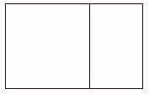

The Golden Mean or Phi occurs frequently in nature and it may be that humans are genetically programmed to recognize the ratio as being pleasing. Studies of top fashion models revealed that their faces have an abundance of the 1.618 ratio.

[tlc.discovery.com/convergence/humanface/articles/mask.html](http://tlc.discovery.com/convergence/humanface/articles/mask.html)

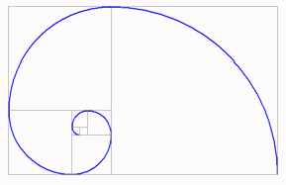

Many photographers and artists are aware of the rule of thirds, where a picture is divided into three sections vertically and horizontally and lines and points of intersection represent places to position important visual elements. The golden ratio and its application are similar although the golden ratio is not as well known and its' points of intersection are closer together. Moving a horizon in a landscape to the position of one third is often more effective than placing it in the middle, but it could also be placed near the bottom one quarter or sixth. There is nothing obligatory about applying the rule of thirds. In placing visual elements for effective composition, one must assess many factors including color, dominance, size and balance together with proportion. Often a certain amount of imbalance or tension can make an image more effective. This is where we come to the artists' intuition and feelings about their subject. Each of us is unique and we should strive to preserve those feelings and impressions about our chosen subject that are different.

|  |  |
| --- | --- |
| http://www.world-mysteries.com/sci_17021.jpg | *Rule of thirds grid applied to a landscape* |
| http://www.world-mysteries.com/sci_17023.jpg | *Golden mean grid applied a simple composition* |

On analyzing some of my favorite photographs by laying down grids (thirds or golden ratio in Adobe Photoshop) I find that some of my images do indeed seem to correspond to the rule of thirds and to a lesser extent the golden ratio, however many do not. I suspect an analysis of other photographers' images would have similar results. There are a few web sites and references to scientific studies that have studied proportion in art and photography but I have not come across any systematic studies that quantified their results- maybe I just need to look harder (see link for more information about the use of the golden ratio:<http://photoinf.com/Golden_Mean/>).  
   
In summary, proportion is an element of design you should always be aware of but you must also realize that other design factors along with your own unique sensitivity about the subject dictates where you should place items in the viewfinder. Understanding proportion and various elements of design are guidelines only and you should always follow your instincts combined with your knowledge. Never be afraid to experiment and try something drastically different, and learn from both your successes and failures. Also try to be open minded about new ways of taking pictures, new techniques, ideas - surround yourself with others that share an open mind and enthusiasm and you will improve your compositional skills quickly.

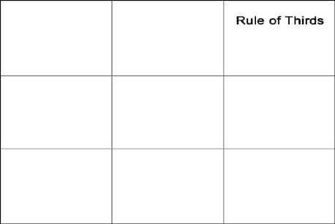

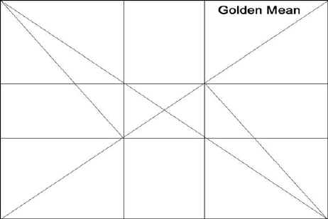

*35 mm film has the dimensions 36 mm by 24 mm (3:2 ratio) - golden mean ration of 1.6 to 1 Points of intersection are recommended as places to position important elements in your picture.*

*Note:  The above segment is part of the article*COMPOSITION & the ELEMENTS of VISUAL DESIGN by Robert Berdan ( <http://www.scienceandart.org/> )

*© R. Berdan 20/01/2004  Published with permission of the author.****The entire article can be found here (PDF):***<http://www.scienceandart.org/photography/elementsofdesign.pdf>

**Subject Related****Links and Resources**

[[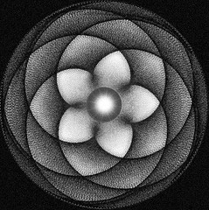](http://www.world-mysteries.com/sar_sage1.htm#Dance)  
Dance of the Planets](http://www.world-mysteries.com/sar_sage1.htm#Dance)

* [BLUEPRINTS OF THE COSMOS](http://www.world-mysteries.com/newgw/sci_blueprint1.htm) - by Christine Sterne \*\*\*\*\*/\*\*\*\*\*